**Assignment 5**

import numpy as np

import tensorflow as tf

import keras.backend as K

from tensorflow.keras.models import Sequential

from keras.layers import Dense, Embedding, Lambda

from keras.utils import np_utils

from keras.preprocessing import sequence

from keras.preprocessing.text import Tokenizer

import gensim

data=open('covid.txt','r')

corona_data = [text for text in data if text.count(' ') >= 2]

vectorize = Tokenizer()

vectorize.fit_on_texts(corona_data)

corona_data = vectorize.texts_to_sequences(corona_data)

total_vocab = sum(len(s) for s in corona_data)

word_count = len(vectorize.word_index) + 1

window_size = 2

def cbow_model(data, window_size, total_vocab):

total_length = window_size*2

for text in data:

text_len = len(text)

for idx, word in enumerate(text):

context_word = []

target = []

begin = idx - window_size

end = idx + window_size + 1

context_word.append([text[i] for i in range(begin, end) if 0 <= i < text_len and i != idx])

target.append(word)

contextual = sequence.pad_sequences(context_word, total_length=total_length)

final_target = np_utils.to_categorical(target, total_vocab)

yield(contextual, final_target)

model = Sequential()

model.add(Embedding(input_dim=total_vocab, output_dim=100, input_length=window_size*2))

model.add(Lambda(lambda x: K.mean(x, axis=1), output_shape=(100,)))

model.add(Dense(total_vocab, activation='softmax'))

model.compile(loss='categorical_crossentropy', optimizer='adam')

for i in range(20):

cost = 0

for x, y in cbow_model(data, window_size, total_vocab):

cost += model.train_on_batch(contextual, final_target)

print(i, cost)

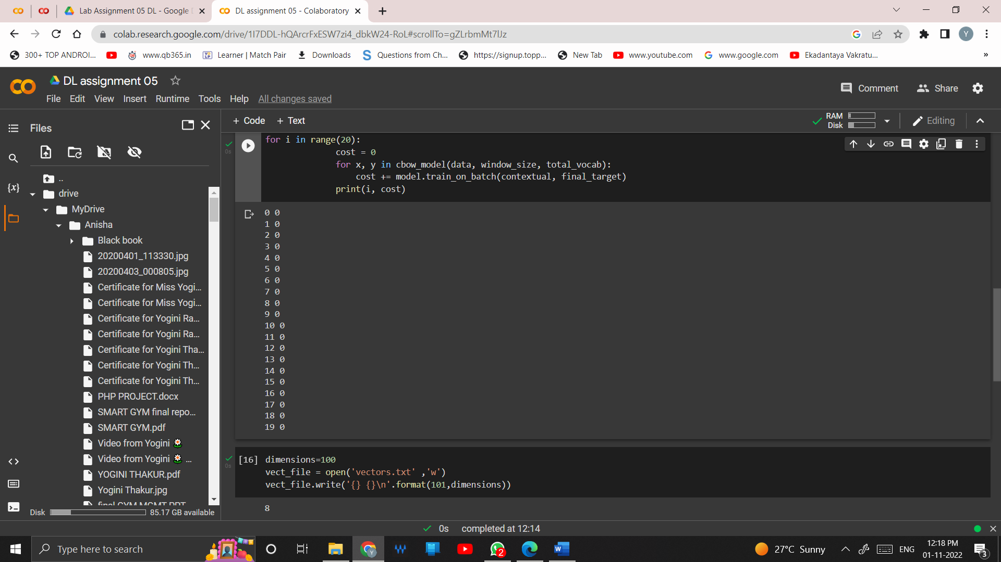

dimensions=100

vect_file = open('vectors.txt' ,'w')

vect_file.write('{} {}\n'.format(101,dimensions))

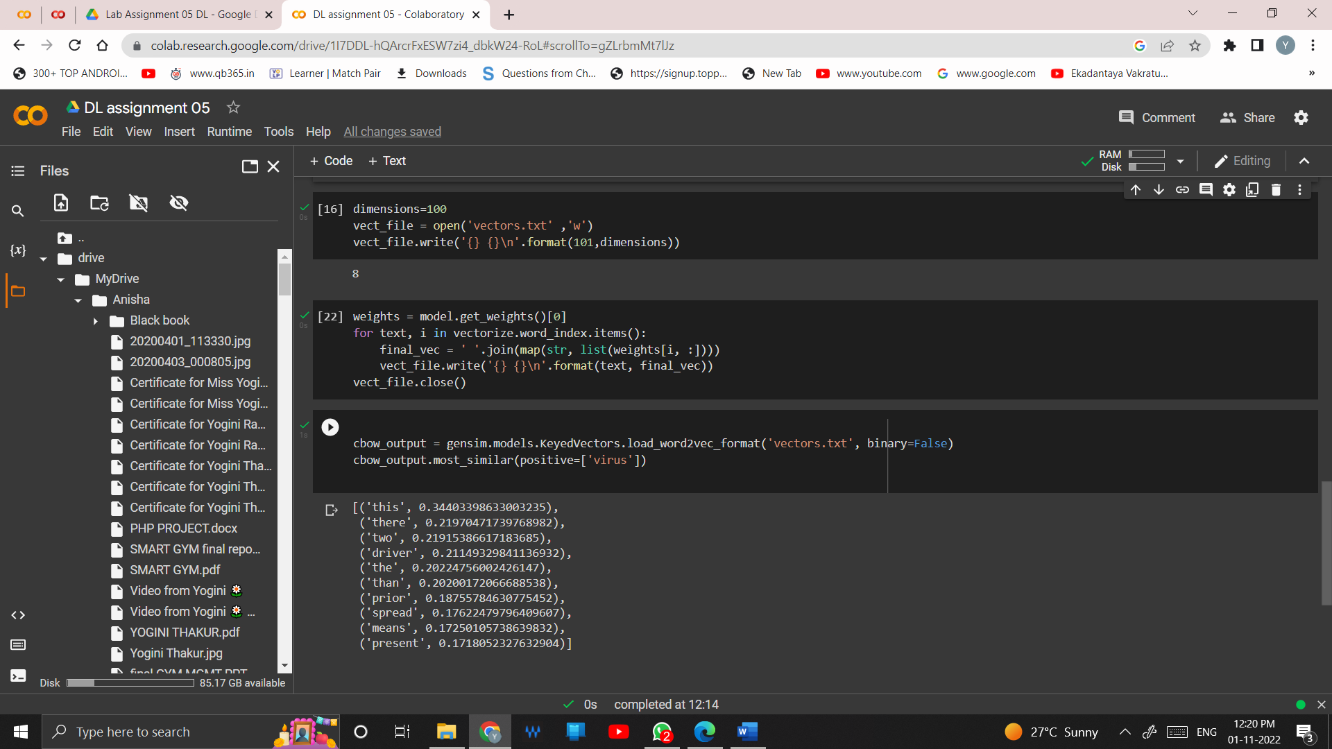

weights = model.get_weights()[0]

for text, i in vectorize.word_index.items():

final_vec = ' '.join(map(str, list(weights[i, :])))

vect_file.write('{} {}\n'.format(text, final_vec))

vect_file.close()

cbow_output = gensim.models.KeyedVectors.load_word2vec_format('vectors.txt', binary=False)

cbow_output.most_similar(positive=['virus'])

